Error: Reference source not found
For Quiz Web Application–
Document ID: 0000.doc
Author: PL Priyadharshini
Version: 1.0
Date: April 14, 2024

1. Objective and Scope 3
2. Project End Users 3
3. Features 4
3.1 User Authentication 4
3.2 Forgot Password Option 4
3.3 Quiz Taking 4
3.4 Instant Correction 4
3.5 Feedback on Selected Answer 6
3.6 Score Calculation 7

Objective and Scope
The objective and scope of the project are to develop a Quiz Application capable of providing interactive quizzes for educational, training, or entertainment purposes. The application should facilitate participation in quizzes across various subjects and topics.
The scope of the product includes the following basic features:
- Sign In and Sign up buttons are provided for user authentication. The navigation bar includes tags: "For School", "For College", "For Business", and "About Us".
- User Accessible from the homepage, allowing users to sign in or sign up.
- Offers easy access to different sections, such as specific quizzes for schools, colleges, and businesses, as well as an "About Us" section.
- After signing in, users are directed to the quiz page, where they can select quizzes based on their institution type or preference.
- Begins with the homepage, offering authentication options and navigation to relevant sections, leading users to the quiz page for interactive participation.

Project End Users
The end users for the quiz website project include students, teachers, professionals, businesses, and administrators.

Features

User Authentication
Each and every user should be authenticated with a User Name and Password to login into the system.
Validations for User Name and Password.
User Name: It accepts only 10 digits mobile number.
Password: It can be anything of the users’ choice.

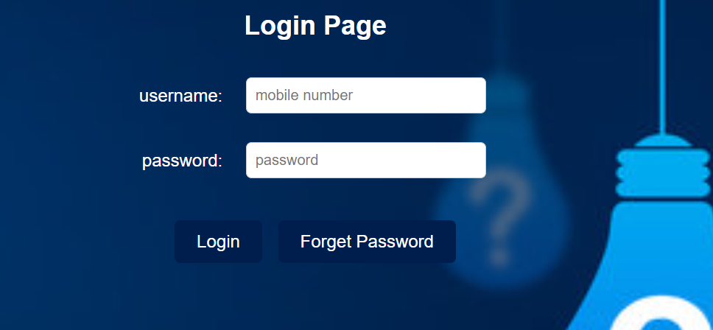

Forgot Password Option
Users can request a password reset via email if they forget their password.


Quiz Taking
Users take quizzes based on their level and selected categories.
Instant feedback on quiz completion.

Instant Correction
When a user clicks on a wrong answer during the quiz, the correct answer is immediately highlighted or displayed for reference.

Feedback on Selected Answer
If a user clicks on the correct answer, it will be indicated in green.
If a user clicks on the wrong answer, it will be indicated in red and also indicate correct answer in green.
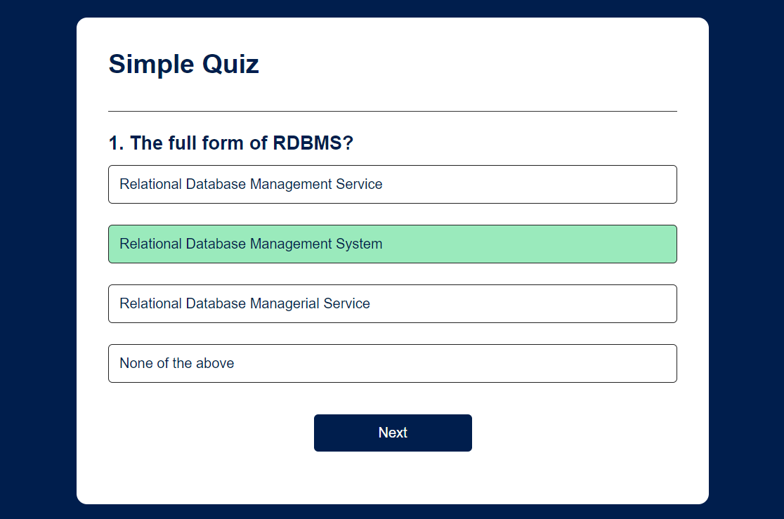
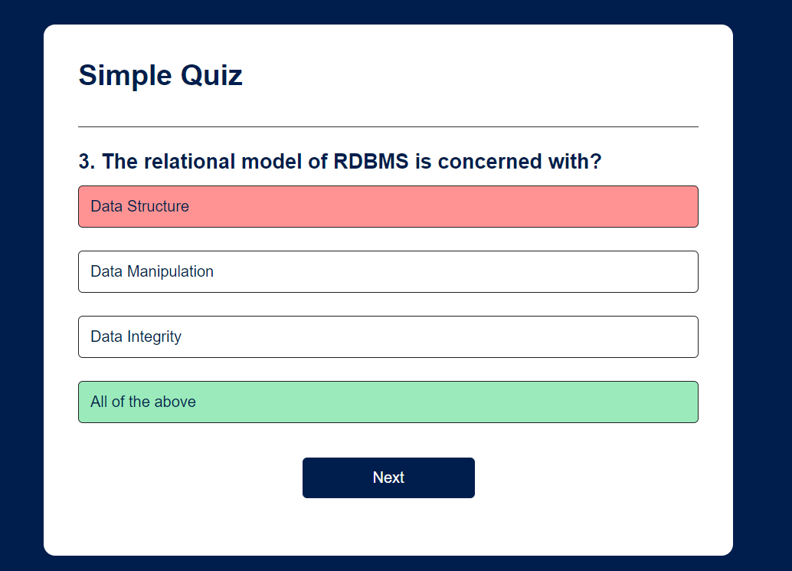

Score Calculation
After submitting the quiz, the user's score is calculated based on the number of correct answers.
Feedback on quiz completion includes the final score achieved by the user.
